**Code analysis from maven:**

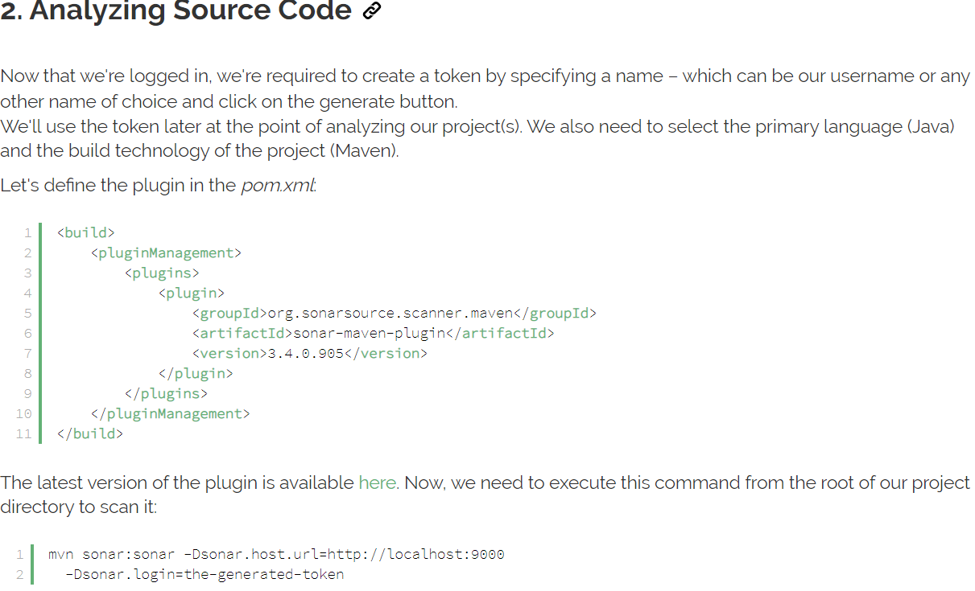

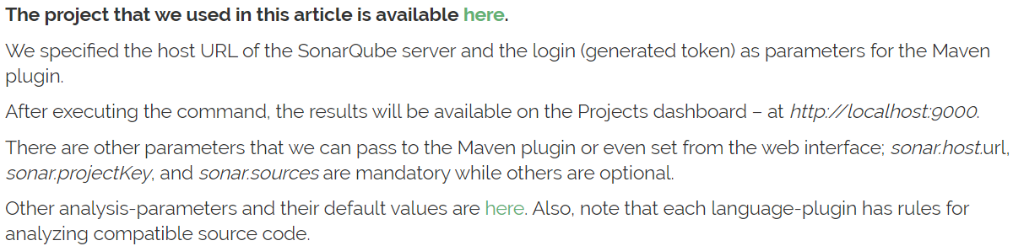

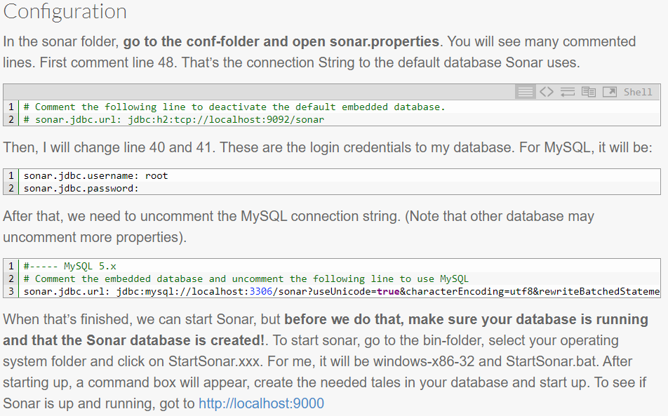

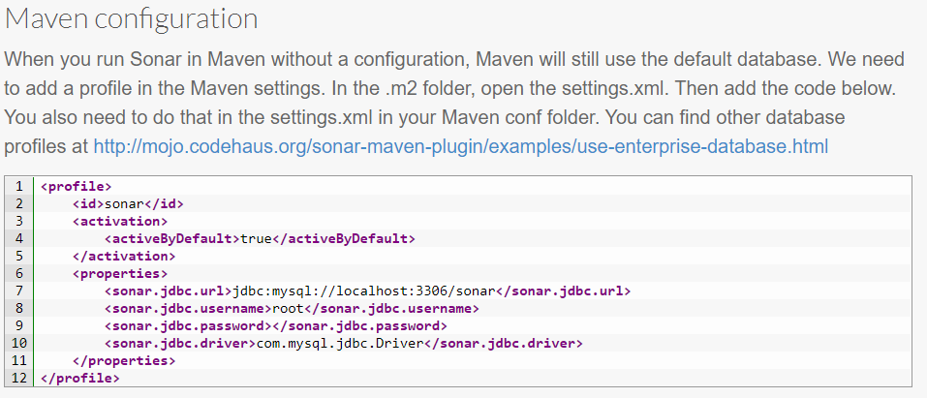

Below is the sample MVN command

mvn sonar:sonar -Dsonar.host.url=https://tdsdevson.eyasp.in/ -Dsonar.scm.disabled=true -Dsonar.projectName=ADMINISTRATION -Dsonar.projectKey=ADMINISTRATION -Dsonar.login=1bad290f3d2528a6e00b003ca843e2336d5d4492

